**§4 Regression Diagnostics**

**Objectives:** after the study of regression diagnostics has been completed, students will be able to:

* State regression assumptions
* Explain what each regression assumption means
* Identify the key components of a regression diagnostics exercise
* Identify the statistical tools used in performing regression diagnostics
* Explain how each of the statistical tools in a regression diagnostics exercise works, and how the results obtained from each tool are interpreted
* Perform a start-to-finish regression diagnostics workup (using SAS and/or R), including:
  + Checking for clean data
  + Examining the validity of regression assumptions
  + Identifying outliers
  + Checking for multicollinearity
* Identify potential remedies for issues identified during the diagnostics exercise
* Report on regression diagnostics findings

**§4.1.0 Introduction**

We have learned about the assumptions behind the simple and multiple linear regression models (see §3.1.5). These assumptions must not be severely (“grossly”) violated in a regression analysis if model inferences are to be valid, and the results are to be believed. We must, therefore, be able to check the validity of the assumptions. Please note: we will be looking for gross violations of assumptions only; mild or moderate violations will not be a problem --classical regression analysis is robust against mild or moderate violations of assumptions.

Besides gross violations of regression assumptions, other serious issues can exist which can corrupt regression analysis results: incorrect data values, outliers and “multicollinearity”. “Regression Diagnostics” is the name for the set of techniques used to investigate the validity of our regression analysis. The key components of a regression diagnostics workup are described below.

**§4.1.1 Check for Clean Data**

The first phase in regression diagnostics work involves a close examination of the data on Y and the independent variable(s). Do the numbers for each variable make sense? Are they all within plausible limits? Did any data entry or coding errors occur? We must answer questions like these, and correct any problems that we find, before using the data in a regression analysis. This is accomplished by examining summary statistics (5 number summary, frequency listings, extreme observation listing) and plots (stem-and-leaf or histogram, boxplots, etc) for each variable (dependent and independent). We should, at the very least, be able to detect the most obvious of the errors and implausible values in the data in this way.

Note that we must be careful not to automatically discard data values that are deemed questionable. Instead, we should first attempt to verify (by going back to original records, whenever possible) that the data are in fact incorrect. If they are, then every attempt must be made to determine the correct value(s). If the correct value cannot be determined, only then should the value be set to missing (note that the entire observation usually should NOT be deleted). If it is not possible to conclusively and objectively determine that a questionable data point is in error, then it should not be deleted.

We will see an example of this phase of our regression work in a later example.

**§4.1.2 Graphical Residual Analysis (Checking for Assumption Violations)**

Several of the assumptions of linear regression can be checked using a few easily constructed graphs.

1. **Simple Scatterplot of Y vs X** (for a simple linear regression of Y on X)

The linearity assumption for simple linear regression can be checked informally using this plot. We have done this several times in lab.

1. **Partial plots of Y vs Xi, i=1,…,k** (for a multiple regression of Y on X1, …, Xk)

In a multiple regression, analysts often will look at K simple scatterplots (or even a (K+1) x (K+1) matrix of each of the K+1 variables in the regression model plotted against each other). That is a ok way to start. However, in multiple linear regression, the linearity assumption should ultimately be checked using *partial plots* (also known as ‘partial residual plots’ or ‘partial regression residual plots’) rather than simple scatterplots of Y versus each X. This is because a simple scatterplot of Y vs Xi does not in any way take into account the other independent variables in the multiple regression. Since there may be relationships between the independent variables, it is important to adjust or control for these relationships when viewing scatterplots.

A partial plot of Y vs X1 is a scatterplot that is adjusted for (i.e. that ‘controls for the effects of’) all other independent variables (X2,…,Xk). Partial plots are easily obtained in SAS using the ‘PARTIAL’ option on the MODEL statement in PROC REG. However, the plots are not easy to create by hand. Here is how the plots would be created by hand:

Suppose that we are checking assumptions for a linear regression of Y on X1, X2 and X3. The partial plot of Y vs X1 is created as follows:

* the vertical axis values for the plotted points consist of the residuals from the regression of **Y on X2 and X3**. Intuitively, these residuals represent that ‘part’ of Y that does not depend on X2 and X3. Another way to say this is that these residuals represent Y after adjusting for X2 and X3.
* The horizontal axis values for the plotted points consist of the residuals from the regression of **X1 on X2 and X3**. Intuitively, these residuals represent that ‘part’ of X1 that does not depend on X2 and X3. Another way to say this is that these residuals represent X1 after adjusting for X2 and X3.

The partial plot therefore represents a plot of that part of Y that does not depend on X2 and X3 versus that part of X1 that does not depend on X2 and X3. It is a plot of Y vs X free from the influence of the other independent variables.

Partial plots of Y vs X2 and Y vs X3 would also be necessary for this regression, and they would be constructed similarly.

Once the partial plots have been obtained, they are used in the same way as an ordinary scatterplot in simple linear regression: if a linear relationship is apparent, then the linearity assumption is probably valid; if a distinctly non-linear relationship is apparent, there may be a violation of the assumption requiring modification of the model (see examples below.) If absolutely no relationship is apparent, then no action will be necessary --the independent variable in question will probably be insignificant in the multiple regression model. In a multiple regression with k independent variables, there would be k partial plots to inspect.

**Example:** Partial plots for a multiple linear regression of Y on X1, X2, and X3. See the plots on the next page.

In plot a, a linear relationship is evident between Y and X1 after controlling for X2 and X3 (no violation of the linearity assumption.) In plot b, a curvilinear relationship exists between Y and X2, controlling for X1 and X3; linearity is violated, and the model may need to be transformed to account for the curvature (perhaps using 1/X22 instead of X2.) In plot c, no relationship seems to exist between Y and X3, controlling for the effects of X1 and X2; X3 will probably be insignificant in the multiple linear regression of Y on X1, X2 and X3, and the analyst will need to consider whether or not the variable should be removed from the model.

Plot a: Partial plot of Y vs X1: Plot b: Partial plot of Y vs X2:

Plot c: Partial plot of Y vs X3:

[In the plots above, the tick mark labels were omitted on purpose; these labels would represent *residual values* from the regressions needed to create the partial plot, and are not useful for interpretation purposes. The variable names on the axis have been changed from Y to Y*, X1 to X1*, to reinforce the idea that the values being plotted are not the actual values of the dependent and independent variables, but residuals from the regressions described above.]

1. **Plot of Residuals vs Predicted Values** (for both simple and multiple linear regression)

A plot of the residuals,  versus the predicted values, , (known as a ‘residual plot’) is informative in several ways. Remember that the residuals are estimates of the error in the model. Since the error is assumed to be random and, on average, equal to zero, we would expect the plotted values to be displayed with no apparent pattern and to be distributed evenly around the line ei = 0. If they are not (i.e. if a [pattern is evident) then the error is not random, and some kind of assumption violation must have occurred.

Examine the plots on the next page. If a residual plot shows a pattern such as the linear and curved patterns in plots a and b below, then a violation of *linearity* has probably occurred. If the plot shows that the spread of the residuals varies with the value of , then the homoscedasticity assumption has been violated (see residual plot c). Finally, it may be possible to check the independence assumption using a residual plot. For example, consider residual plot d, from a simple linear regression of cholesterol level (Y) on age (X).The square plotting points represent data from males, the dots data from females. Clearly, the residuals depend on gender, and are not, therefore, independent. Note that if the same plotting symbol had been used for all data points, the lack of independence would not have been detected; so, sometimes, detecting assumption violations using these plots requires good experience, subject-matter knowledge and even creativity on the part of the analyst.

Residual Plot a: Residual Plot b:

Residual Plot c: Residual Plot D:

If the data in a study were collected over time, it might be helpful to plot the residuals over time to detect any lack of independence due to a time-effect.

The graphs above show us how to use the residual plot with the predicted value of Y on the horizontal axis to detect gross violations of linearity, homoscedasticity and independence. If gross violations are found, it is often useful to plot the residuals vs. each independent variable, to determine which variable is involved in the violation. For example, if the residual plot with Yhat on the horizontal axis has a grossly curved appearance, then by plotting the same residuals vs. X1, X2, X3 etc. we can determine whether the non-linearly problem involves X1, or X2, or X3; this might help us determine how to remedy the violation; for example, to remedy a non-linear relationship between Y and X2, we might transform Y or transform X2 or both (see section on remedies below).

1. **Normal Probability Plot and Histogram of the Residuals**

The normality assumption can be checked by inspecting a normal probability plot and a histogram of the residuals. These are produced by default by PROC REG when ODS graphics is on. Note that in many real-life analyses, the subjective decision as to whether there is a gross violation of the normality assumption or not can be difficult to make. In such cases, it is recommended that the analyst also consider the results of normality tests such as the Shapiro-Wilk and Kolmogorov tests as well as others produced by SAS’s PROC UNIVARIATE (you will have to output the residuals from PROC REG to a data set in order to run PROC UNIVARIATE on them –check with a lab instructor on how to do that). If the burden of the evidence indicates no gross lack of normality, then it should be concluded that there is no gross violation of the normality assumption that needs to be remedied.

**§4.1.3 Regression Diagnostics: Ways to Fix Assumption Violations**

1. Transformations. See pp. 371-372 in the Kleinbaum text.

2) Weighted Least Squares

3) Non-parametric techniques

4) Call your statistician. Treating assumption violations can be tricky. It can involve “playing” with

transformations and advanced techniques, sometimes without adequate resolution of the problem; and,

sometimes, transformations correct one assumption violation but introduce other violations!

**§4.2 Outlier Detection and Treatment**

Assumption violations are not the only problems that can arise in a regression analysis. Outliers can also pose difficulties. An observation is an outlier if it lies "far away" from the main body of the data. Outliers may represent errors in the data and/or they may “influence” the regression estimates:

An observation can be an outlier with respect to the independent variables, or with respect to the dependent variable, or with respect to both:

Visually, gross outliers can often be detected on scatterplots of Y vs X (for SLR) or on partial plots (in multiple regression). However, some important outliers may not be detectable in this manner; for these outliers, we will consider three numerical detection measures. Don't worry about the actual formulas for these measures, or about all the mathematical details presented in Kleinbaum’s book. Just learn the basic ideas behind the measures, and learn how to apply them to a real data set!

1) Leverage values (“hi”...the index i represents the observation number): used to detect outliers with respect to the independent variables. hi is, roughly speaking, a measure of the distance of an observation from the "center" of the independent variable values.

If hi > 2(k+1)/n, then observation i has been identified as an outlier with respect to the independent variables, and should be scrutinized more carefully.

2) Cook's Distance (di): detects outliers with respect to the independent and /or dependent variables. di is a measure of the influence of the ith observation on the estimates of j 's. If di > 4/n then observation i has been identified as an influential outlier, and should be scrutinized more carefully.

3) Jacknife residuals (r-i). Detects outliers w.r.t. the independent and /or dependent variables. r-i is the residual standardized in such a way as to prevent the observation from masking its own effect. (What is "masking"?).

If the absolute value of r-i is greater than 2, then observation i has been identified as a moderately influential outlier, and should be scrutinized more carefully (why choose 2? Think about it.) Note: some people will use the more stringent cutoff of 3 (looking only for severe outliers rather than moderately influential outliers). And other people use a still more refined cutoff: if r-i is greater than tn-k-2, 0.05/2, it is an influential outlier.

**Treating Outliers**: Once an observation has been identified as an outlier, the values of Y, X1, X2 etc. that make up that observation need to be scrutinized, and the offending value(s) located. It must then be judged as to whether the values are incorrect (in which case every effort should be made to correct the value). If it is not possible to say for sure that a value is incorrect, then a judgment must be made as to whether or not it is plausible. If plausible, the value must be left alone. If not plausible, the value should be set to missing. The judgment regarding plausibility should be made after very careful, scientific consideration; the decision to set a value to missing should not be taken lightly.

Sometimes, an entire observation must be thrown out completely because all or most of the values for that observation are judged to be impossible. HOWEVER, this situation should arise very rarely. The decision to throw out an observation should not be taken lightly.

**Diagnostics Example: Bodyfat regressed on triceps skinfold thickness and thigh circumference**

ods graphics on /imagemap=on;

**data** one; input subject triceps thigh bodyfat @@; datalines;

1 19.5 43.1 11.9 2 24.7 49.8 22.8

3 30.7 51.9 18.7 4 29.8 54.3 20.1

5 19.1 42.2 12.9 6 25.6 53.9 2.17

7 31.4 58.5 27.1 8 27.9 52.1 25.4

9 22.1 49.9 21.3 10 25.5 53.5 19.3

11 31.1 56.6 25.4 12 30.4 56.7 27.2

13 18.7 46.5 11.7 14 19.7 44.2 17.8

15 14.6 42.7 12.8 16 29.5 54.4 23.9

17 27.7 55.3 22.6 18 30.2 58.6 25.4

19 22.7 48.2 14.8 20 25.2 51.0 12.1

;

run;

********************************************************;

* FIRST DO DESCRIPTIVE STATISTICS ;

********************************************************;

**proc** **univariate** plot data=one;

var triceps thigh bodyfat;

run;

********************************************************;

* CORRECT DATA ERRORS FOUND ;

********************************************************;

**data** two; set one;

if subject=**6** then bodyfat=**21.7**;

run;

********************************************************;

* RUN THE REGRESSION...BUT WE WILL FOCUS ON OUTLIER ;

* DETECTION BEFORE ACTUALLY LOOKING AT MODEL ESTIMATES ;

********************************************************;

**proc** **reg** data=two;

model bodyfat=triceps thigh /influence r;

run;

********************************************************;

* OUTLIER CORRECTION AND THEN RE-RUN REGRESSION ;

********************************************************;

**data** three;

set two;

if subject=**20** then bodyfat=**21.1**;

run;

********************************************************;

* RE-RUN PROC REG & PERFORM GRAPHICAL RESIDUAL ANALYSIS ;

********************************************************;

**proc** **reg** data=three;

model bodyfat=triceps thigh

/partial

vif;

*Above: ‘partial’ produces partial plots

‘vif’ produces variance inflation factors used to

Detect collinearity;

run;

**SAS Program for Regression Diagnostics**

**(Analyst’s choice: Use alpha=0.1)**

**Original and Correct Paper Record of the Data**

1 19.5 43.1 11.9

2 24.7 49.8 22.8

3 30.7 51.9 18.7

4 29.8 54.3 20.1

5 19.1 42.2 12.9

6 25.6 53.9 21.7

7 31.4 58.5 27.1

8 27.9 52.1 25.4

9 22.1 49.9 21.3

10 25.5 53.5 19.3

11 31.1 56.6 25.4

12 30.4 56.7 27.2

13 18.7 46.5 11.7

14 19.7 44.2 17.8

15 14.6 42.7 12.8

16 29.5 54.4 23.9

17 27.7 55.3 22.6

18 30.2 58.6 25.4

19 22.7 48.2 14.8

20 25.2 51.0 21.1

The UNIVARIATE Procedure

Variable: triceps

Moments

N 20 Sum Weights 20

Mean 25.305 Sum Observations 506.1

Std Deviation 5.02325906 Variance 25.2331316

Skewness -0.5318842 Kurtosis -0.7945173

Uncorrected SS 13286.29 Corrected SS 479.4295

Coeff Variation 19.8508558 Std Error Mean 1.12323487

Basic Statistical Measures

Location Variability

Mean 25.30500 Std Deviation 5.02326

Median 25.55000 Variance 25.23313

Mode . Range 16.80000

Interquartile Range 9.10000

Extreme Observations

----Lowest---- ----Highest---

Value Obs Value Obs

14.6 15 30.2 18

18.7 13 30.4 12

19.1 5 30.7 3

19.5 1 31.1 11

19.7 14 31.4 7

_________________________________________________________________________________________________

The UNIVARIATE Procedure

Variable: thigh

Moments

N 20 Sum Weights 20

Mean 51.17 Sum Observations 1023.4

Std Deviation 5.23461153 Variance 27.4011579

Skewness -0.417494 Kurtosis -0.9315992

Uncorrected SS 52888 Corrected SS 520.622

Coeff Variation 10.2298447 Std Error Mean 1.17049472

Basic Statistical Measures

Location Variability

Mean 51.17000 Std Deviation 5.23461

Median 52.00000 Variance 27.40116

Mode . Range 16.40000

Interquartile Range 7.50000

Extreme Observations

----Lowest---- ----Highest---

Value Obs Value Obs

42.2 5 55.3 17

42.7 15 56.6 11

43.1 1 56.7 12

44.2 14 58.5 7

46.5 13 58.6 18

_________________________________________________________________________________________________

The UNIVARIATE Procedure

Variable: bodyfat

Moments

N 20 Sum Weights 20

Mean 18.7685 Sum Observations 375.37

Std Deviation 6.65715703 Variance 44.3177397

Skewness -0.7327395 Kurtosis 0.21978709

Uncorrected SS 7887.1689 Corrected SS 842.037055

Coeff Variation 35.4698406 Std Error Mean 1.48858557

Basic Statistical Measures

Location Variability

Mean 18.76850 Std Deviation 6.65716

Median 19.70000 Variance 44.31774

Mode 25.40000 Range 25.03000

Interquartile Range 11.80000

Extreme Observations

-----Lowest---- ----Highest---

Value Obs Value Obs

2.17 6 25.4 8

11.70 13 25.4 11

11.90 1 25.4 18

12.10 20 27.1 7

12.80 15 27.2 12

__________________________________________________________________________________________________

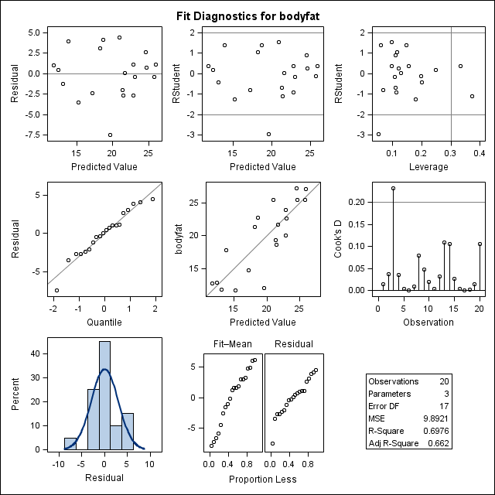Plot from first PROG REG

Output from Second PROC REG run:

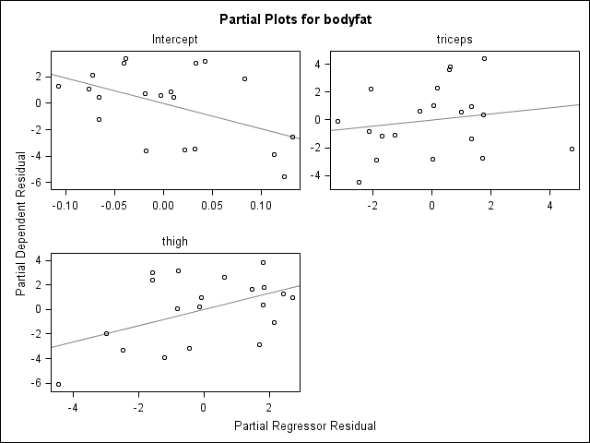

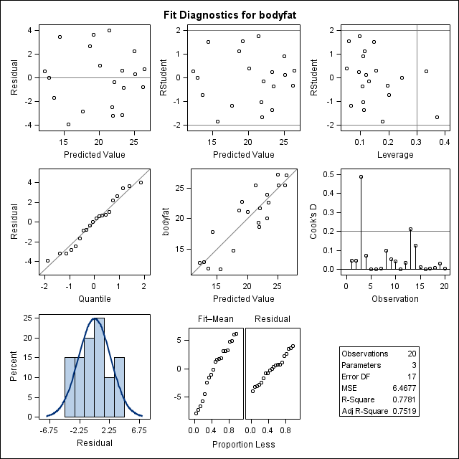

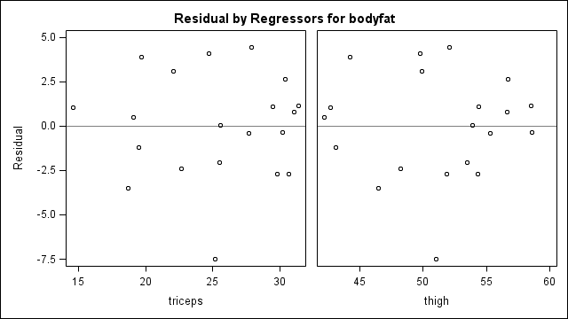

Model: MODEL1

Dependent Variable: bodyfat

Number of Observations Read 20

Number of Observations Used 20

Analysis of Variance

Sum of Mean

Source DF Squares Square F Value Pr > F

Model 2 385.43871 192.71935 29.80 <.0001

Error 17 109.95079 6.46769

Corrected Total 19 495.38950

Root MSE 2.54317 R-Square 0.7781

Dependent Mean 20.19500 Adj R-Sq 0.7519

Coeff Var 12.59305

Parameter Estimates

Parameter Standard

Variable DF Estimate Error t Value Pr > |t|

Intercept 1 -19.17425 8.36064 -2.29 0.0348

triceps 1 0.22235 0.30344 0.73 0.4737

thigh 1 0.65942 0.29119 2.26 0.0369

**§4.3 Multicollinearity**

Multicollinearity (or collinearity) is a problem that can result in inaccurate estimates of regression coefficients, standard errors of coefficients and p-values for inferences in a multiple linear regression. It exists when *independent variables* are strongly linearly associated with *each other*.

Symptoms of multicollinearity:

1. Large correlations *between the independent variables*.
2. Large changes in estimates of regression coefficients, and/or in their standard errors when independent variables or observations are added/deleted.
3. Large standard errors for the estimated coefficients.
4. Non-significant results for regression coefficients that should be significant
5. Wrong signs on slope coefficient estimates.
6. Overall test for regression significant, but partial tests insignificant.

7. Large variance inflation factors (VIF's …see below)

# Example: Regressions were run with: Y = body fat, X1 = triceps skinfold thickness, X2 = Thigh circumference, X3 = Midarm circumference. The independent variables were added sequentially to the model (so 3 regressions were run.) The following Symptoms of collinearity were noted:

1. Large correlations between the X’s:

Correlation Matrix:

Y X1 X2 X3

Y 1 .843 .878 .142

X1 1 .924 .458

X2 1 .085

X3 1

1. Unstable regression results; parameter estimates and/or partial test results change substantially each time a new variable is added to the model:

Estimate of reg. model with X1:  = -1.496 + 0.8572X1

* overall test significant

Estimate of reg. model with X1, X2:  = -19.174 + 0.2224X1 + 0.6594X2

* overall test significant
* partial test for X1 not significant
* partial test for X2 significant

Estimate of reg. model with X1, X2 & X3: = 117.08 + 4.333X1 - 2.857X2 - 2.186X3

* none of partial tests are significant!
* the sign of  has changed!

**§4.3.1 Variance Inflation Factors: A Tool for Detecting Multicollinearity**

Variance Inflation Factors (VIF) are statistics that can be used to confirm the presence of collinearity in a multiple regression. One VIF is calculated for each independent variable; a VIF ( > 10) is usually considered to be indicative of collinearity; however, note that values “close” to 10 are also worth noting. For the jth independent variable, Xj, the VIF is: VIFj = 1 / (1 - R2Xj | all other X's),

where R2Xj | all other X's = SSR/SSXj from the regression of Xj on all the other independent variables. That is, R2Xj | all other X's is the r-squared value from this regression:

Xj = β0 + β1X1 + β2X2 + …+ βj-1Xj-1 + βj+1Xj+1+…+βkXK + E

For the example above, the VIFs were calculated to be:

VIF(X1) = 709

VIF(X2) = 654

VIF(X3) = 105

Note: Some software packages report a related measure: tolerance (TOL) = 1/VIF

Clearly, severe collinearities exist in the bodyfat data, since all the VIF’s were > 10. The fact that all were large, and the fact that they were *much larger* than 10 indicates that the collinearity is extremely severe here.

**§5.3.2 Remedies for Multicollinearity**

Remedying multicollinearity problems can be difficult. The possible solutions are:

1. The easiest and most often implemented remedy is to remove one or more of the variables that have high VIFs, in iterative fashion: remove a collinear variable, re-run the model, re-examine VIFs, remove another collinear variable if necessary, and so on until the VIFs are no longer large. Variables with high VIFs should be selected for removal based on subject-matter concerns, and not on the basis of p-values (since the latter are not reliable in the presence of severe collinearity).
2. Specialized statistical techniques such as Ridge Regression. For more read *Applied Linear Statistical Models* by Kutner, Nachtschiem, Wasserman and Neter.
3. Break the pattern of collinearity by collecting observations where the linear relationships between the independent variables do not hold. This is sometimes possible in experimental studies, but may not be possible at all in observational studies.
4. In observational studies, collect larger quantities of data; larger datasets are more likely to contain observations in which the problematic linear relationships do not hold.
5. Use “centered” independent variables; that is, use in place of . This may work when the original model was in polynomial form (that is, the original model was like the following: Y = β0 +β1X1 + β2X22 +…+E).

Example: in the body fat example, perform a collinearity analysis

********************************************************;

* Collinearity analysis;

********************************************************;

**proc** **reg** data=three;

model bodyfat=triceps thigh/vif;

*vif produces variance inflation factors;

run;

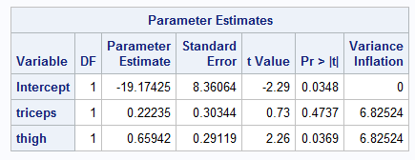

Example: in the body fat example, data were also collected on midarm circumference…perform a collinearity analysis

********************************************************;

* Collinearity analysis;

********************************************************;

**proc** **reg** data=three;

model bodyfat=triceps thigh/vif;

*vif produces variance inflation factors;

run;

**proc** **corr** data=one plots=matrix;

var bodyfat triceps midarm thigh;

**run**;

